**Lecture: Variable Substitution**

Variables are key components to the flexibility of playbooks, we will take a look at the two most common methods of using them

Vi vartest.yaml

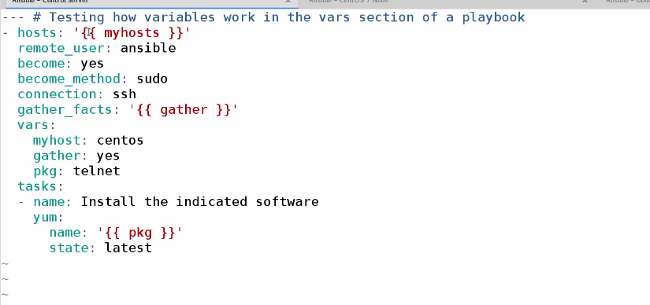

Littile mistake .(spell mistake myhost)

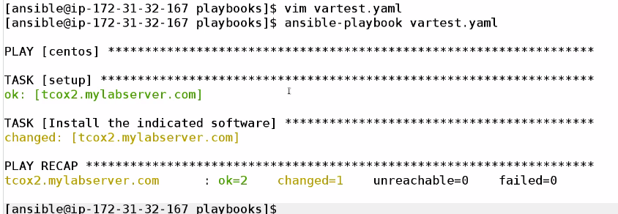

Cleaning using ansible command not playbook

Now gonna create another varsubtitute.yaml (remove the var section )

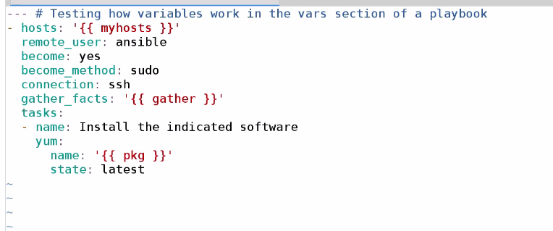if we run now got that variable not defined

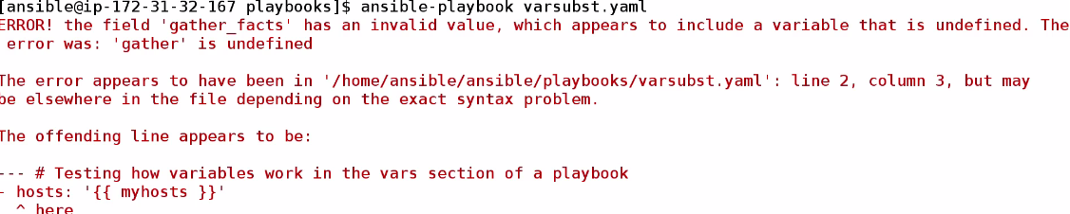

Giving variable value runtime

